
Walamoo Tax System



Table of Contents
Login Page 2
Walamoo Tax Page 3
Settings 4
Tax System Information 5
View number of cities by country 6
Tax Information Upload 7
Enter Query 8
Monthly Scenarios 9
Thresholds Settings 10
Reconciliation 11
Registration Form 12
Help Center Page 13

Login Page
Below you will see a “Login Page” screen, while you’re on this page you will need to enter your username and password then press the “Login” button.
Enter your username in this text box
Enter your password in this text box
This is the welcome screen.

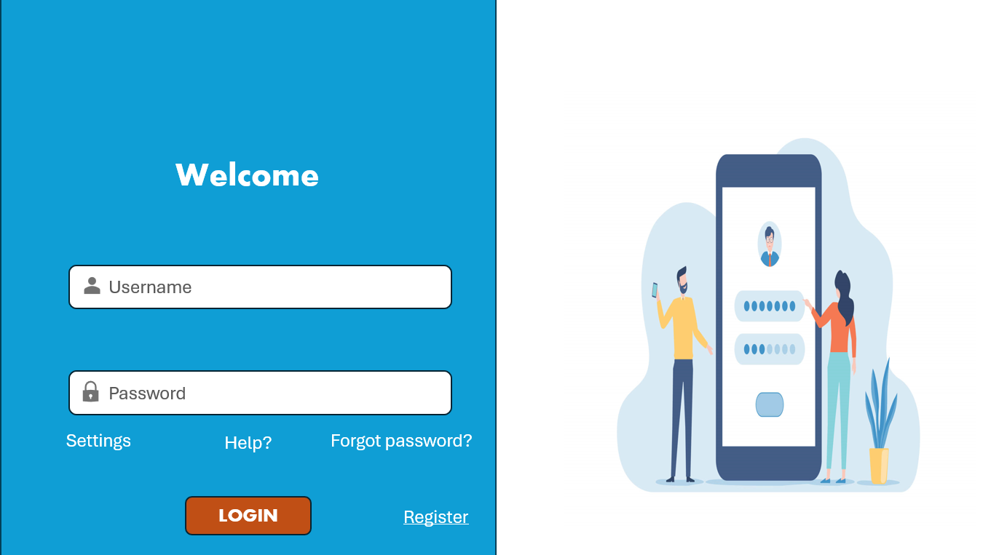
This button will carry you to the forgotten password page
This button will carry you to registration page
This button will carry you to the help page
This button will log you into the Walamoo Tax Page
Button will carry you to the Settings Page

If you haven't created an account yet, you can simply right-click on the "Register" button. Alternatively, you can navigate to the Table of Contents and find the "Registration Form" page for more detailed information on how to proceed with registration.

Walamoo Tax Page
This button will give you a search bar.
This button will give a drop down menu to other pages


This button will carry you to the tax information upload page
This button will carry you to the Welcome page
This button will carry you to the Help Center page

When you enter the “Walamoo Tax” page, to upload your tax information click the “Upload Now” button , the red button on you bottom left will send you right back to the home page , the search menu will show you all the other pages on the application, the message icon will carry you to the “Help Center” if there is any queries you need clarity on, the search icon will allow you to search for anything on the application .

Settings
This is a drop-down menu to other colors.
This is a drop-down menu to other font size.

This is a drop-down menu to other font style.

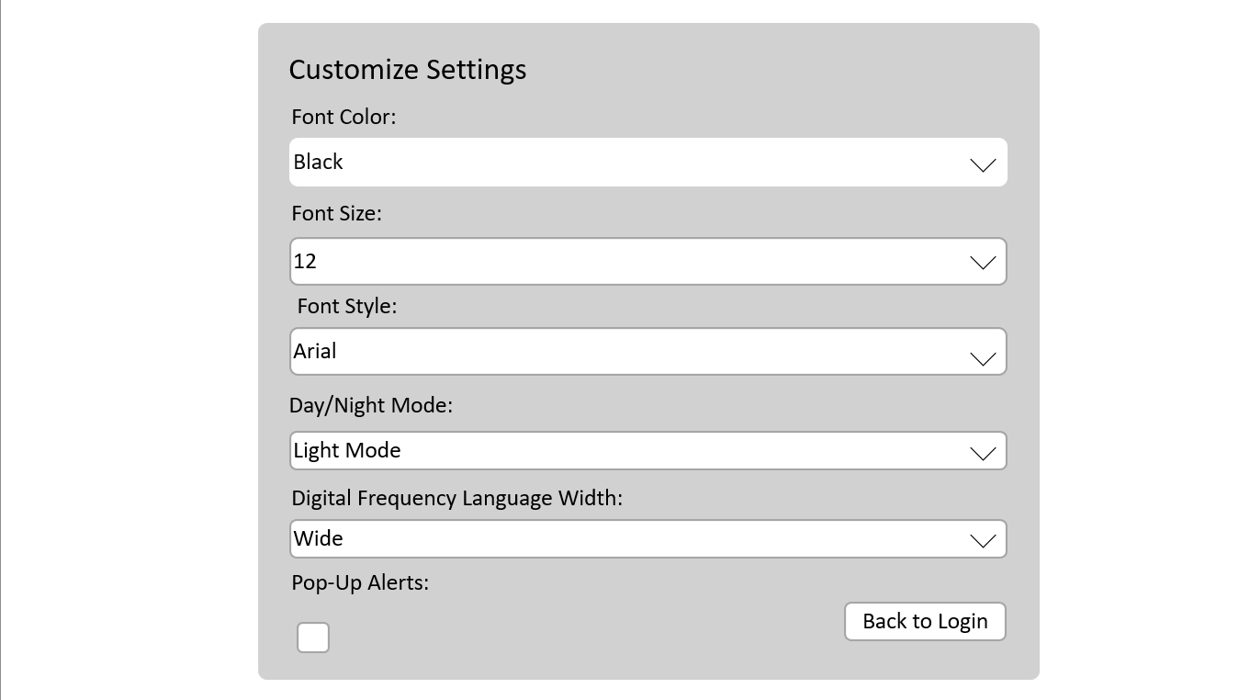
This is a drop-down menu to language width.

This button this check box
This button takes you to login page
This is a drop-down menu to Day and night mode.

In the “Settings” page, allow you to change the settings suited for you, you can change the colour, font, font size, font style, the day and night setting and the digital frequency language width, pop up notification are optional to you if you need it.

Tax System Information

This button will carry you to the Walamoo Tax page

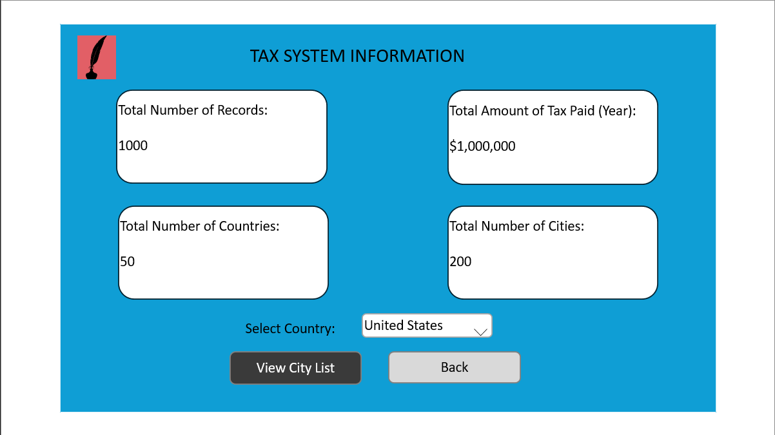
This is a drop-down menu select other countries.

This button carries you back to the walamoo tax page
This button allows you to view the number of cities of a country

The “Tax System Information” page allows to view your tax information, the “View City List” button will show the number of cities within a country , to select specified country you will use the drop down menu to select the country you want to view, to go back to the previous page hit the “back” button, to go back to the tax page click on the “tax page icon” on the top right.

View number of cities by country
Information changes base on county selected and the number of cities they have

This button will carry you to the Walamoo Tax page

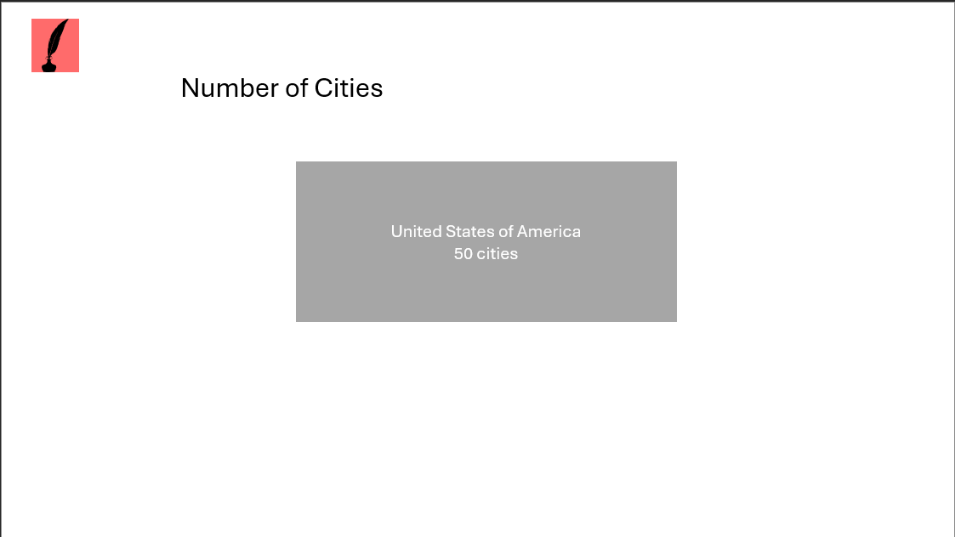

This page shows the number of cities in each country you have selected.

Tax Information Upload
This button will carry you to the Walamoo Tax page

This button will allow you to upload a XML file

This button will allow you to reupload a XML file

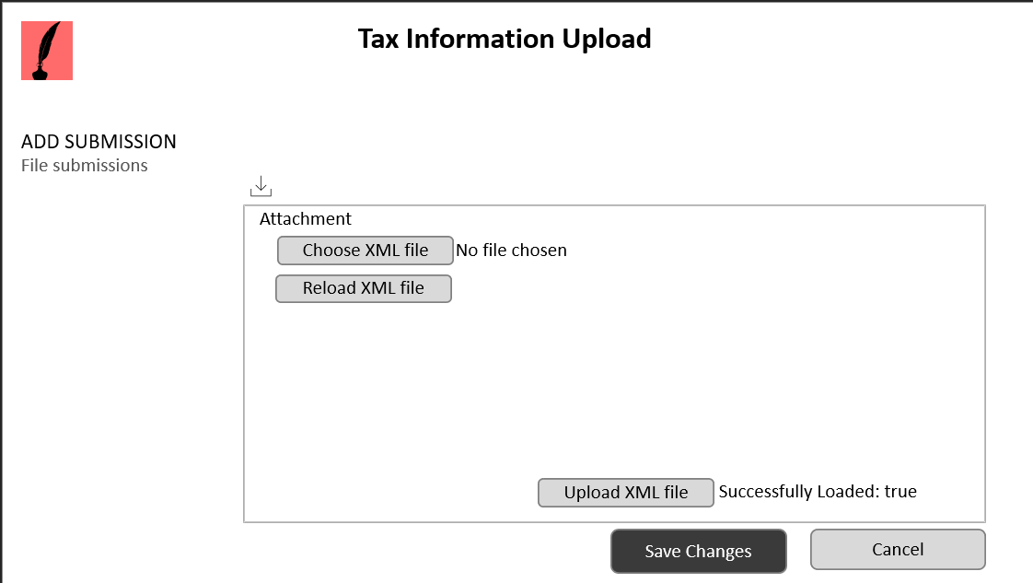
Your able to drag and drop files
This button will allow you to upload a XML file

This button will save the uploaded file

This button will carry you to the Walamoo Tax page

For the “Tax System Information Upload” page, you will upload your files by clicking “Choose XML File”. You also can reupload any files in case the information contains errors or is incorrect by clicking the “reupload XML file” button.
Hit the “upload XML file” button to upload your information. After uploading the appropriate file. Click “Save Changes”.

Enter Query

Query results show here
Queries can be entered here
This button will carry you to the Walamoo Tax page

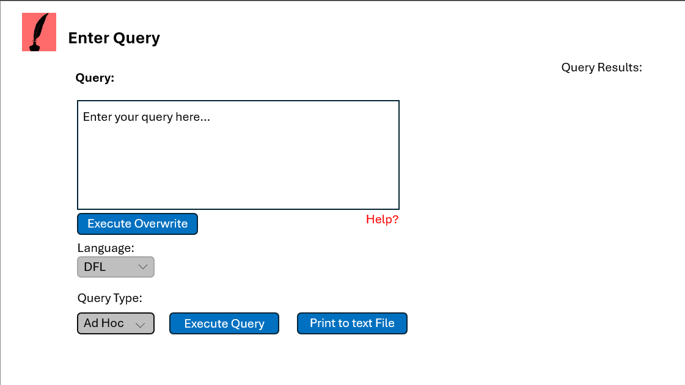
This button forces an execute overwrite

This button will carry you to a help page

This button gives a drop-down menu select of Language types

This button gives a drop-down menu select of other Query types

This button executes the query

This button prints query to a text file

The "Enter Query" page facilitates the process of submitting queries for clarification. Simply input your query into the designated textbox labeled "Enter your query here..." To specify the language type, use the dropdown menu provided. Additionally, you can adjust the query type using the corresponding dropdown menu.
Once you've configured your query, click the "Execute Query" button to complete the process. If you wish to save the query to a text file, click "Print to Text File." For further assistance, press the "Help" button. Your query results will be displayed in the top right corner under "Query Results."

Monthly Scenarios

This button gives a drop-down menu select of the months

This button will carry you to the Walamoo Tax page

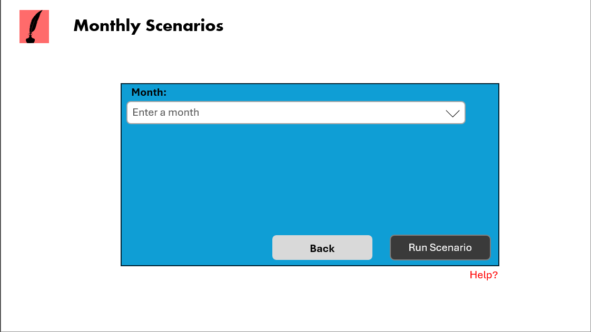
This button will carry you back to????

This button run the Scenario

This button will carry you to a help page

The “Monthly Scenario”page facilitates the execution of monthly scenarios based on your requirements. Simply utilise the drop-down menu to select the desired month, then click the "Run Scenario" button to execute it.
If you need to return to the previous page, you can do so by using the back button. Additionally, for further assistance, feel free to click the help button, which provides additional guidance as needed.

Thresholds Settings
This button will carry you to the Walamoo Tax page

Text box to enter the Thresholds value
This button gives a drop-down menu select of minimum tax

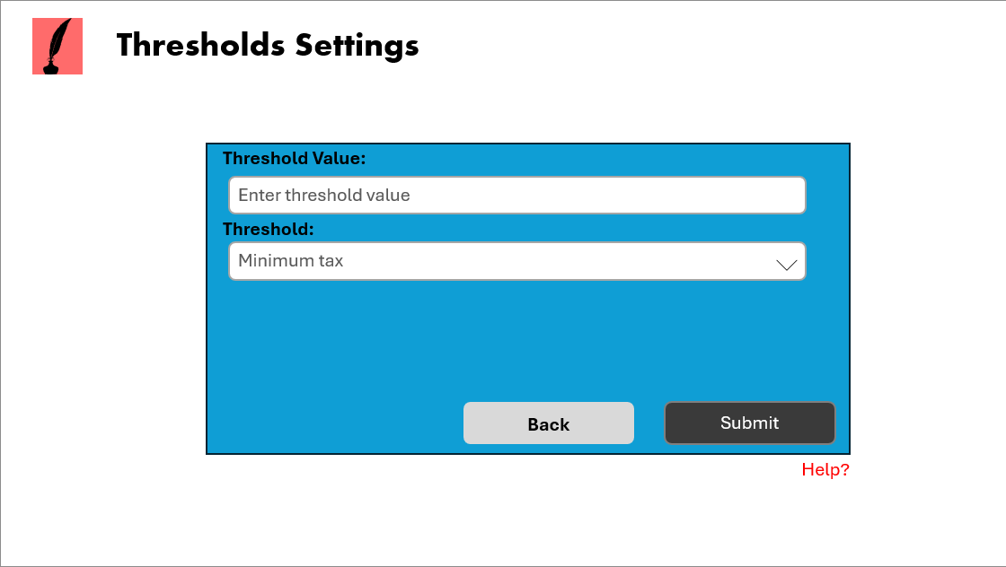
This button submits the threshold value and minimum tax

This button will carry you back to????

This button will carry you to a help page

On this page, you can set the threshold value and corresponding threshold tax. Simply input the desired threshold value into the provided text box and select the appropriate tax from the dropdown menu.
After making your selections, click the "Submit" button to confirm and apply the threshold and tax settings. To return to the previous page, use the back button. If you require further assistance, feel free to utilize the red help button.

Reconciliation

This button will carry you to the Walamoo Tax page

Difference between total taxes paid show here
Text box to enter the Deposit value

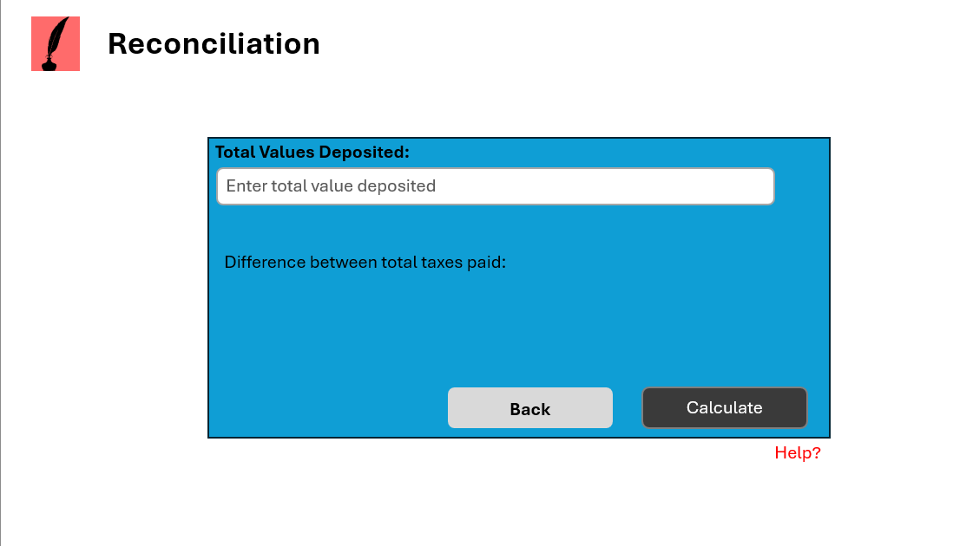
This button will carry out calculations

This button will carry you back to????

This button will carry you to a help page

On the “Reconciliation” page, you have the option to deposit funds by entering the desired amount into the designated text box.
After inputting the amount, simply click the "Calculate" button to determine the variance between the total taxes paid. If you need assistance beyond this, you can access additional help by clicking the red help button. To return to the previous page, utilize the back button.

Registration Form
Text box to enter the Last Name
Text box to enter the First Name

This button will carry you to the Walamoo Tax page

Text box to enter the Last Name
Text box to enter your Country

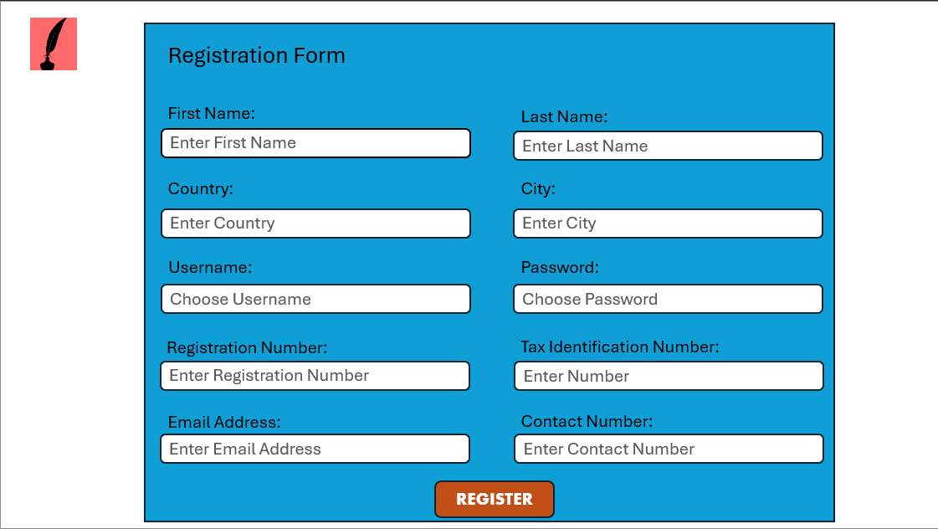
Text box to enter the Last Name
Text box to enter the Last Name
Text box to enter the Email Address

Text box to enter the Contact number

Text box to enter the Registration number
Text box to enter the Tax Identification Number
This button will register users

On the "Registration Form" screen displayed above, you will find designated text boxes for entering your personal information. These fields include: first name, last name, country, city, username, password, registration number, tax identification number, email, address, and contact number.
Once you have inputted all the required information, kindly proceed by clicking the "REGISTER" button to complete the registration process.

Help Center Page
This button will carry you to the Walamoo Tax page

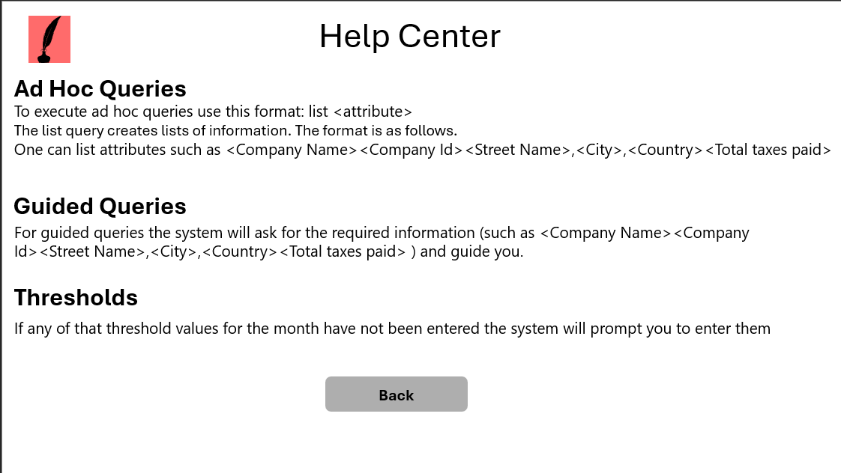
Returns you to previous page

The "Help Center" page provides tailored assistance based on your specific inquiry. If you require support, simply input your query to receive guidance. If you don't require assistance, you can easily navigate back to the previous page by clicking the back button.

